**AZURE SYNAPSE DATA PIPELINE CODING CHALLENGE**

**Name: S.Nikhil Sai**

**Date: 19-12-2024**

STEP 1: Open azure synapse and click on new linked service .

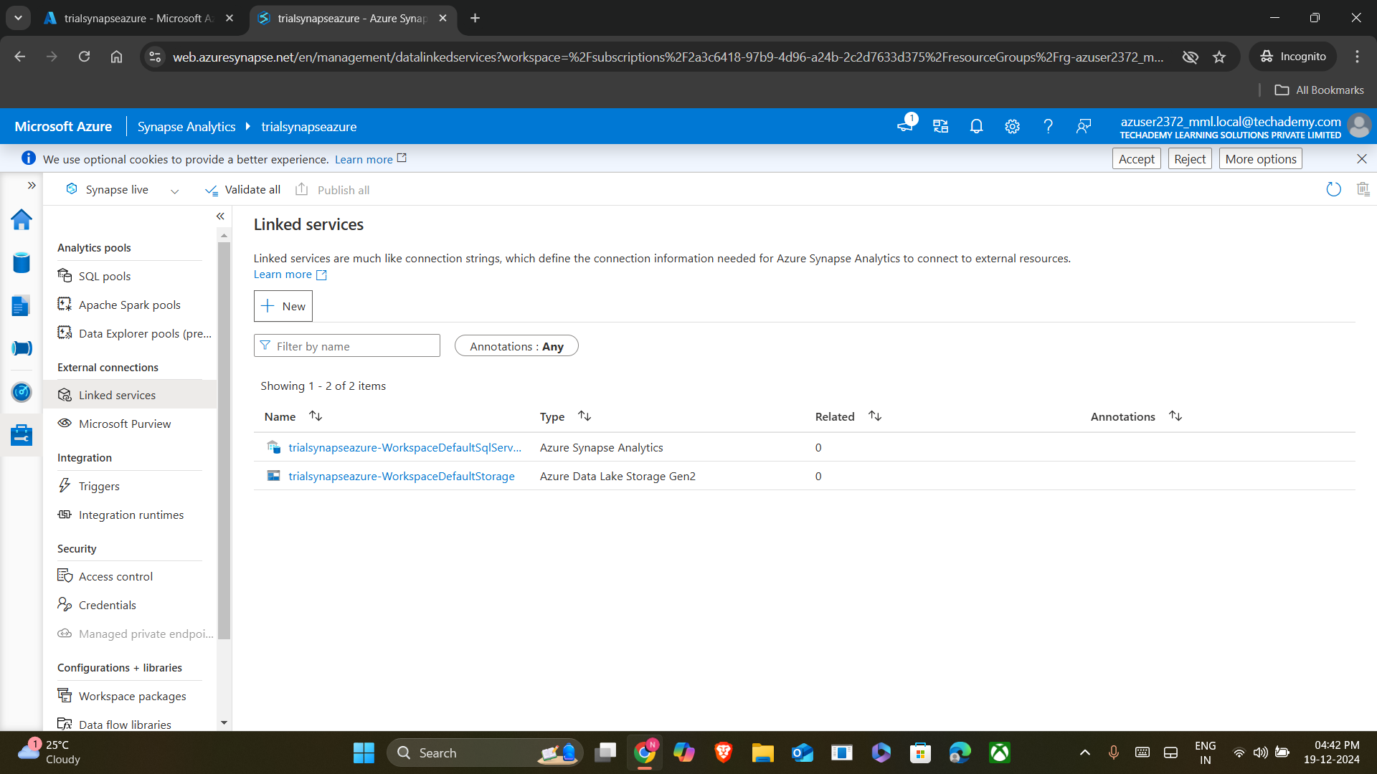

STEP 2: Select databricks to link in a new service

STEP 3: Give proper name, select subscription, workspace name while linking the service.

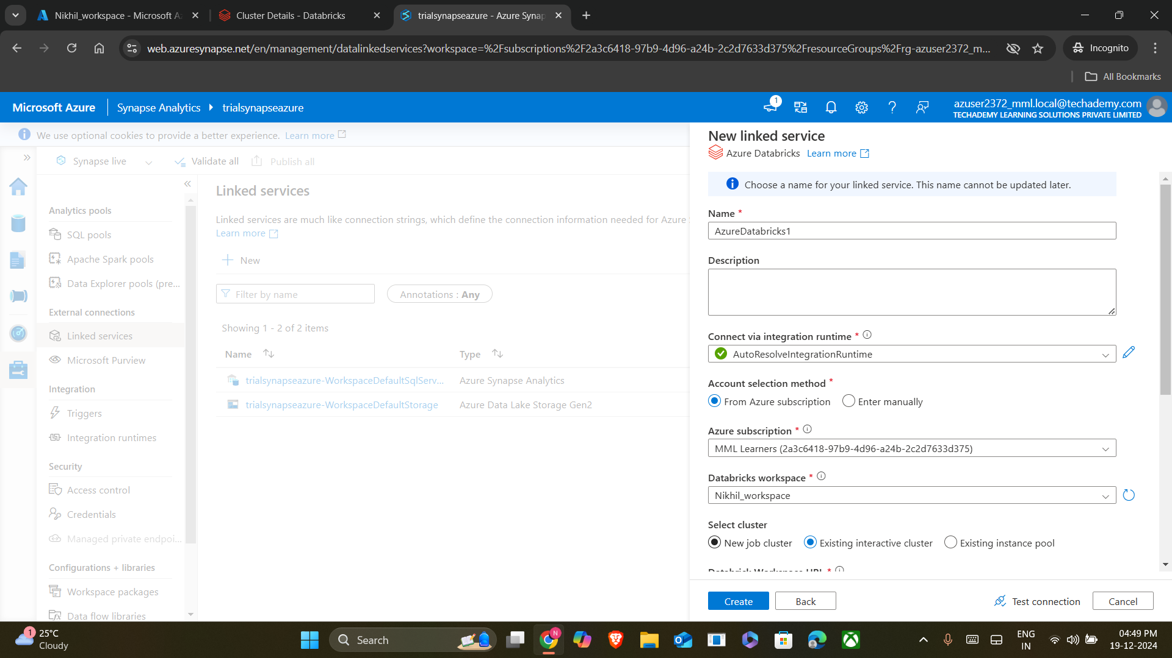

STEP 4: Select the existing cluster used in databricks. Provide a valid Access token to connect the data bricks.

STEP 5: Now click on integrate and create new pipeline . After creating pipeline, drag and drop db notebook.

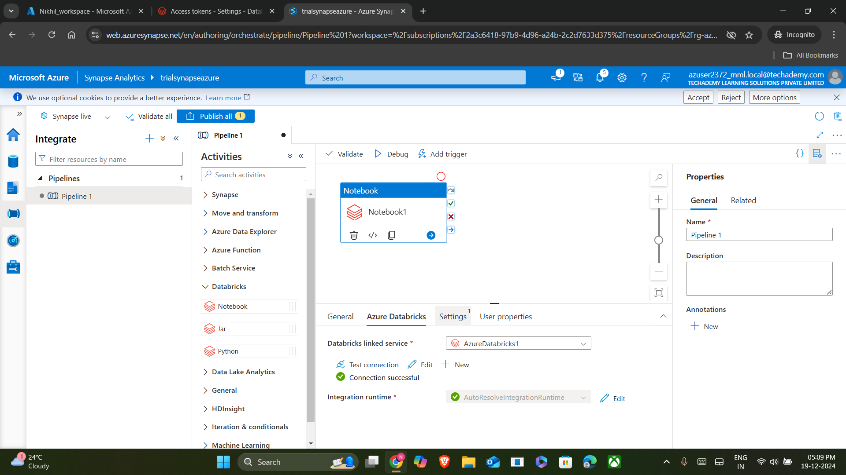

STEP 6: Now give proper configuration to the selected notebook by linking it with data bricks.

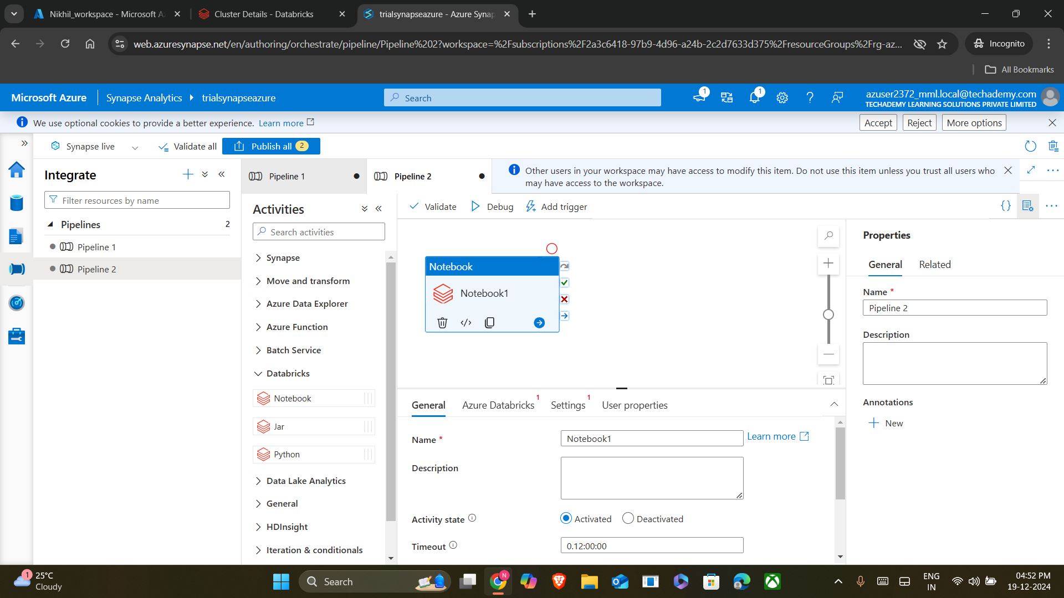

STEP 7: Select the ipynb file from data bricks that has to be used in the pipeline.

STEP 8: After configuring the pipeline, validate it and debug.

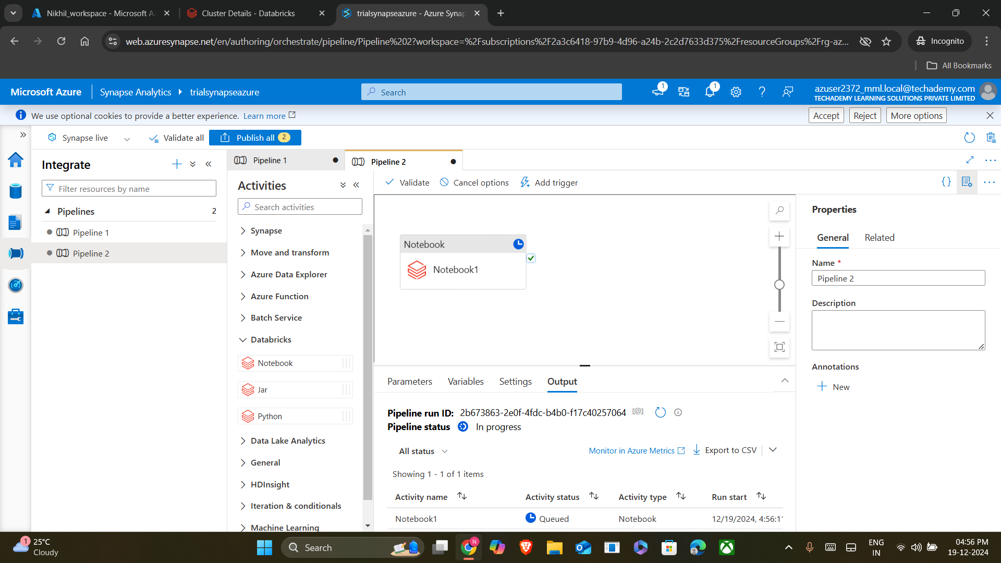

STEP 9: Therefore, the pipeline has successfully runned the attached notebook.

